**Personal Task Manager**

**Module Name:**  Software Development 1

**Module leader**: Guhanathan Poravi

**Assignment type:** Individual coursework

**Group ID**: 8

**Submission date:** 21/04/2025

|  |  |  |
| --- | --- | --- |
| **Student Id** | **Uow ID** | **Student Name** |
| 20240138 | W2153129 | S.Thanushan |

Table of Contents

List of Tables i

List of Figures i

Program Description 2

Introduction 2

Test Plan 2

Test cases 3

Screen shots of test frames 4

Screen shots of json format 7

Conclusion 8

# List of Tables

Table 1Test cases 3

# List of Figures

Figure 1Design and ready to add a task 4

Figure 2 Edit option 4

Figure 3 Delete option 5

Figure 4 Filtering by name 5

Figure 5 Filtering by priorities 6

Figure 6 Filtering by due date 6

Figure 7 Details saving to file in json format 7

# Program Description

* Task management functions as a crucial element for productivity because it enables users to monitor their work activities and set priorities for tasks while sustaining an efficient workflow. The main goal of this project involves creating a Personal Task Manager application which provides basic functionality for users to create new tasks and modify existing ones and view tasks and perform task deletions.

# Introduction

* Testing procedure for the Personal Task Manager project, including Stage 3 and Stage 4 development phases, is described in this paper. Using JSON for data storage with organized data, stage three is concerned with a transition from list-based to dictionary-based task management. With the help of Tkinter, Stage 4 adds a graphical user interface (GUI) that enables effective viewing, searching, and sorting of tasks. To guarantee that all important features—e.g., creation, editing, deletion of tasks, saving/loading data, and actions on the user interface—are working correctly and perfectly without compromising data integrity and usability is the goal of this testing.

# Test Plan

* Back-end operation unit tests and manual tests for GUI interactions are both included in the test plan. Stage 3 tests validate that task CRUD operations, I/O with JSON files, and error handling for missing or invalid data are all handled correctly. Stage 4 GUI testing checks the responsiveness of the Tkinter application, accuracy of filtering and sorting, and user input handling. On a desktop operating system, the test setup comes with Python 3.x and default libraries json and tkinter. In order to ensure robustness and be confident in the overall system reliability, both functional and boundary cases are taken into account.

# Test cases

|  |  |  |  |  |
| --- | --- | --- | --- | --- |
| Test case No. | Input | Expected Outcome | Actual Outcome | Result |
| 1 | When we input   1. task name 2. Description 3. Mandatory priorities are given we took the priority (High,Medium,Low) 4. Due Date | Typically watermark removed when we click on that tab   1. When we click add task button task will saved in Json file format. | As Expected, | Pass |
| 2 | When we click Edit task button | Existing tasks will show in the mandatory tabs. We can edit the details while details in the tabs.. | As Expected, | Pass |
| 3 | When we click Delete task button | When we click the task in tree view and click delete button that task will deleted. | As Expected, | Pass |
| 4 | When we add task | Automatically add task will show in tree view with color separations.   * High-Red * Medium-Orange * Low-Green | As Expected, | Pass |
| 5 | When we search the task | If we search tasks in the search bar and that task will appear in Tree view. | As Expected, | Pass |
| Filtering option  With (Task details) |

Table 1Test cases

# Screen shots of test frames

Figure 1Design and ready to add a task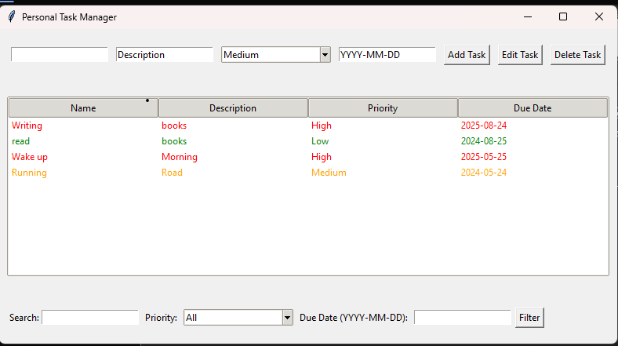

Figure 2 Edit option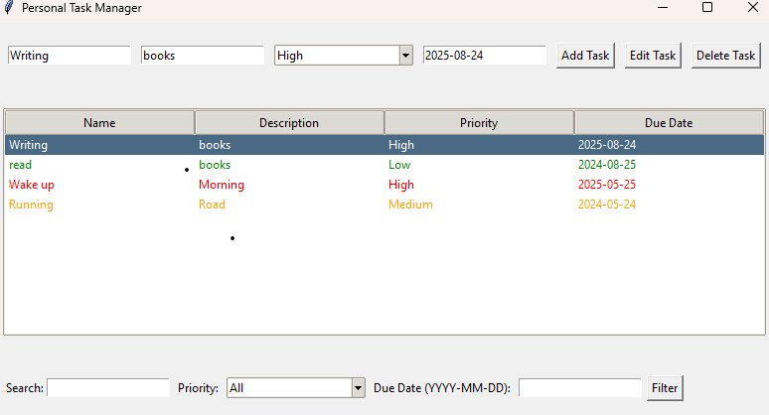

* When we click the task in treeview and click edit button to edit the task details.

Figure 3 Delete optionA screenshot of a computer

AI-generated content may be incorrect.

* When we click the task in the treeview and click the delete button to delete the task.

Figure 4 Filtering by name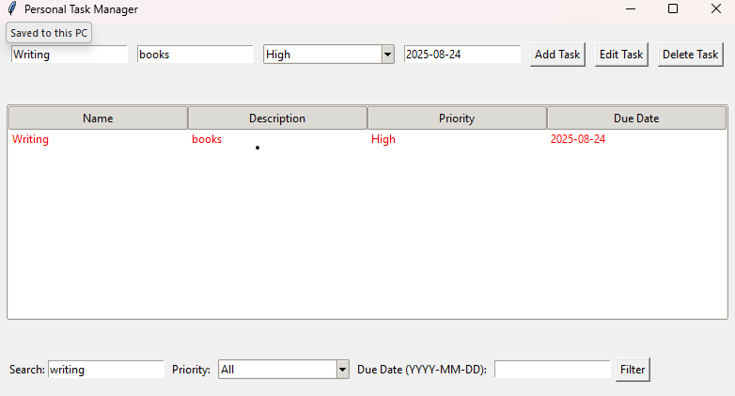

Figure 5 Filtering by prioritiesA screenshot of a computer

AI-generated content may be incorrect.

Figure 6 Filtering by due dateA screenshot of a computer

AI-generated content may be incorrect.

# Screen shots of json format

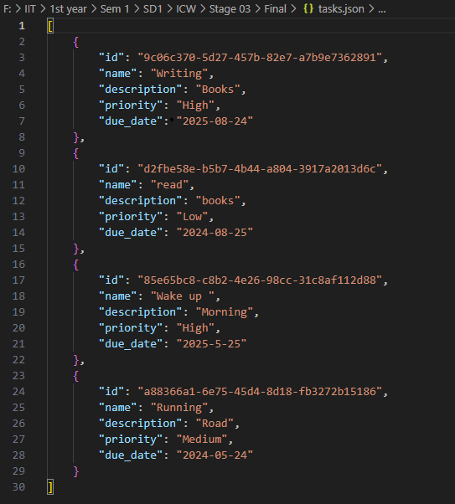

Figure 7 Details saving to file in json format

# Conclusion

Both Stage 3 and Stage 4 testing of the Personal Task Manager application correctly verified the system's main features. All CRUD operations proceeded as planned, and JSON file processing exhibited stable data retrieval and persistence. Usability, filtering, and sorting functionality of the Tkinter GUI had been tested; all of them worked appropriately and improved the user experience. Although there is some potential for minor revisions to improve error handling and responsiveness of the user interface, the program as presented satisfies project requirements and presents a good, user-friendly task management product. The test results provide a high degree of confidence in the overall reliability and functionality of the program.